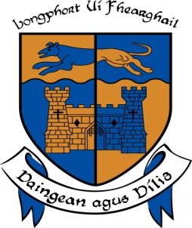

LONGFORD COUNTY COUNCIL

COMHAIRLE CHONTAE AN LONGFOIRT

Minutes of May Monthly Meeting of Longford County Council
held in the Council Chamber, Aras an Chontae, Great Water Street, Longford on
Wednesday, 13th May 2015 at 4.00 p.m.

_______________________________________________________________________

PRESIDING: Councillor Seamus Butler, Leas -Cathaoirleach.

MEMBERS PRESENT: Councillors – Paraic Brady, John Browne, Mick Cahill, Micheál Carrigy, Mark Casey, John Duffy, Gerard Farrell,
Padraig Loughrey, Luie McEntire, Martin Mulleady,
Colm Murray, Pat O’Toole, Peggy Nolan, P.J. Reilly,
Paul Ross, Mae Sexton and Gerry Warnock.

IN ATTENDANCE: Mr. Tim Caffrey, Chief Executive.
Mr. Frank Sheridan, Director of Services.
Mr. Barry Lynch, Director of Services/Head of Finance.
Mr. Ciaran Murphy, Acting Director of Services.

MEETINGS
ADMINISTRATOR: Ms. Anne Lee.

VOTE OF SYMPATHY.

On the proposal of Councillor S. Butler seconded by Councillor M. Sexton, it was unanimously resolved that a vote of sympathy be extended to Councillor Paraic Brady and the Brady family on the death of his Father, Gerry, former County Councillor, and that the meeting be adjourned as a mark of respect.

All members of the Council associated themselves with the vote of sympathy.

Gerry’s exceptional qualities were highlighted by the members and many tributes were paid to Gerry.
Mr. T. Caffrey, Chief Executive, on his own behalf and on behalf of the staff of the County Council associated himself with the vote of sympathy.

It was agreed that the May and June meetings be amalgamated and held on Wednesday,
10th June on Wednesday, 15th April 2015 at 4.00 p.m.

This concluded the business of the meeting.
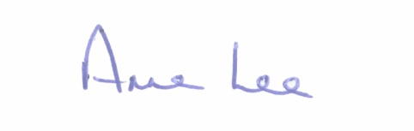

Signed: _______________
Anne Lee,
Meetings Administrator.

Confirmed and adopted at Monthly Meeting of Longford County Council held on the
10th June 2015.

Signed: _______________
Cathaoirleach.

